**An Analysis of Optimal Trajectories for Air Launched Single Stage Rockets**

Dante Sanaei

*Purdue University School of Aeronautics and Astronautics, West Lafayette, Indiana, 47906, USA*

**The following report is an analysis of optimal orbital and suborbital trajectories for single stage rockets that were launched from the air. A time optimal model for orbital insertion was generated and launches from the air and ground were evaluated for several spacecraft. Additionally, range optimized flights were generated for air launched rockets and were compared with trajectories with differing launch angles. Overall, the mission of this paper is to investigate air launched rocketry through time and range optimized launch profiles.**

**I. Introduction**

Since the dawn of rocket technology, ground launches have been the norm. From an economic and safety sense, vertically launching a large rocket from a ground location is simply the best option. Rocket launches require huge amounts of machinery, fuel equipment and other logistical challenges, and having a stationary site for launch allows all of these requirements to be met. But ground launches do come with one major caveat: the rocket must traverse the densest parts of Earth’s atmosphere, and in doing so, waste a large portion of its precious fuel reserves. In order to mitigate the effects of drag loss, some researchers and engineers have proposed launching small rockets at higher altitudes from aircraft, thus removing a significant amount of drag force they would encounter and providing some initial velocity [1].

This paper solely focuses on analyzing optimal trajectories of these novel rocket launch strategies and comparing them to more traditional ground launches. It consists of two sections (A. and B.) of air launched analysis. Section A. develops a time optimal orbital insertion model and analyzes trajectories of air launched, single stage rockets. This section will compare hypothetical Titan II launches from the ground and from aircraft. Trajectories for more realistic air launched spacecraft are generated and evaluated as well. Section B. instead focuses on suborbital trajectories for the more realistic air launched examples discussed in Section A. The suborbital trajectories are optimized for maximum time in space as well as range, and additional analysis is performed on range optimization for missiles launched on the ground and in the air.

There are many different variables to evaluate when considering rocket launches from aircraft, but this paper focuses only on generating optimal trajectories for these novel launch strategies. The results will identify benefits and/or drawbacks of air launches of realistic spacecraft that are being designed today.

**II. Background and Analysis**

The following section will describe the mathematical background and other important parameters behind the two trajectory optimization models that will be used throughout this document. Section A. describes the formulation of a time optimal orbital insertion simulation that incorporates variable mass and drag losses on the spacecraft. Section B. will cover the basic principles of the maximization of range for a constant thrust/mass rocket that experiences no drag loss. Both of these models were created using MATLAB, and the code has been attached in the Appendix.

**A. Time Optimal Orbital Insertion Model**

The MATLAB code for the time optimal launch model was adapted from Appendix B of *Optimal Control with Aerospace Applications*, but the primary mathematical principles will be derived below [2].

If we are to consider a launch of a rocket from a flat earth into a circular orbit with the effects of drag included, the following are the equations of motion,

$$\dot{x}=V_{x}$$

$$\dot{y}=V_{y}$$

$$\dot{V_{x}}=\frac{F}{m}\cos\left(θ\right)-\frac{D}{m}cos⁡(γ)$$

$$\dot{V_{y}}=\frac{F}{m}\sin\left(θ\right)-\frac{D}{m}\sin\left(γ\right)-g$$

Where F is rocket thrust, m is mass, and D is drag force. Drag is calculated in the following equation,

$$D=\frac{1}{2}ρC_{D}A(V_{x}^{2}+V_{y}^{2})$$

Where $C_{D}$ is the drag coefficient, A is the cross-sectional area of the rocket, and $ρ$ is the density of the air. In the case of our model, we will assume that $C_{D}$ is held constant through flight. Additionally, we will use a simple exponential atmosphere model to determine density as a function of altitude. This is shown below,

$$ρ=ρ_{ref}e^{-\frac{y}{h_{scale}}}$$

In order to continue with the optimization, we will employ the Euler-Lagrange equations to form a two-point boundary value problem. To begin, we will find the Hamiltonian,

$$H= L+λ^{T}f= λ_{1}V_{x}+λ_{2}V_{y}-λ_{3}\left(\frac{F}{m}\cos\left(θ\right)-\frac{D}{m}\cos\left(γ\right)\right)+λ_{4}\left(\frac{F}{m}\sin\left(θ\right)-\frac{D}{m}\sin\left(γ\right)-g\right)$$

Use the following to remove $θ$ and $γ$,

$$\cos\left(θ\right)=\frac{-λ_{3}}{\sqrt{λ_{3}^{2}+λ_{4}^{2}}} \sin\left(θ\right)=\frac{-λ_{4}}{\sqrt{λ_{3}^{2}+λ_{4}^{2}}}$$

$$\cos\left(γ\right)=\frac{-V_{x}}{\sqrt{V_{x}^{2}+V_{y}^{2}}} \sin\left(γ\right)=\frac{-V_{y}}{\sqrt{V_{x}^{2}+V_{y}^{2}}}$$

Then,

$$H= λ_{1}V_{x}+λ_{2}V_{y}-λ_{3}\left(\frac{F}{m}\frac{-λ_{3}}{\sqrt{λ_{3}^{2}+λ_{4}^{2}}}-\frac{D}{m}\frac{-V_{x}}{\sqrt{V_{x}^{2}+V_{y}^{2}}}\right)+λ_{4}\left(\frac{F}{m}\frac{-λ_{4}}{\sqrt{λ_{3}^{2}+λ_{4}^{2}}}-\frac{D}{m}\frac{-V_{y}}{\sqrt{V_{x}^{2}+V_{y}^{2}}}{-g}\right)$$

Lastly, replace the drag term,

$$H= λ_{1}V_{x}+λ_{2}V_{y}-\frac{F}{m}\sqrt{λ_{3}^{2}+λ_{4}^{2}}-\left(\frac{ρ_{ref}C_{D}A}{2}e^{-\frac{y}{h_{scale}} }\sqrt{V_{x}^{2}+V_{y}^{2}} (λ_{3}V_{x}+λ_{4}V_{y})\right)-λ_{4}g$$

Now we find the costate equations,

$$\dot{λ_{1}}=-\frac{δH}{δx}= 0$$

$$\dot{λ_{2}}=-\frac{δH}{δy}=\left(λ_{3}V_{x}+λ_{4}V_{y}\right)e^{-\frac{y}{h_{scale}}}\left(\frac{-K_{1}\sqrt{V_{x}^{2}+V_{y}^{2}}}{h_{scale}}\right)$$

$$\dot{λ_{3}}=-\frac{δH}{δV_{x}}= K_{1}e^{-\frac{y}{h_{scale}}}\left[λ_{3}\left(\frac{V_{x}^{2}}{\sqrt{V_{x}^{2}+V_{y}^{2}}}+\sqrt{V_{x}^{2}+V_{y}^{2}}\right)+λ_{4}\frac{V_{x}V_{y}}{\sqrt{V_{x}^{2}+V_{y}^{2}}} \right]$$

$$\dot{λ_{4}}=-\frac{δH}{δV_{y}}= {-λ_{2}+K}_{1}e^{-\frac{y}{h_{scale}}}\left[λ_{3}\left(\frac{V_{x}^{2}}{\sqrt{V_{x}^{2}+V_{y}^{2}}}+\sqrt{V_{x}^{2}+V_{y}^{2}}\right)+λ_{4}\frac{V_{x}V_{y}}{\sqrt{V_{x}^{2}+V_{y}^{2}}} \right]$$

We have 8 boundary conditions and 4 state equations. From the law of 2n+2, we know that two more boundary conditions are required. To find these we use the transversality condition,

$$H_{f}dt_{f}-λ_{f}^{T}dx_{f}+dϕ=0$$

Because $ϕ=t_{f}$ and $x_{f}$ is free the condition becomes,

$$H_{f}dt_{f}-λ_{1f}dx_{f}+dt_{f}=0$$

Thus,

$H_{f}=-1$ and $λ_{1f}=0$

In order to aid with the computational complexity that arises in this problem, the main variables will be scaled. We will define them with the following,

$$\overline{x}=\frac{x}{h}, \overline{y}=\frac{y}{h}, \overline{V_{x}}=\frac{V_{x}}{h}, \overline{V_{y}}=\frac{V_{y}}{h}$$

Now we can obtain a well-defined TPBVP:

$$\dot{\overline{x}}=\overline{V_{x}}\frac{V_{c}}{h}$$

$$\dot{y}=\overline{V_{y}}\frac{V_{c}}{h}$$

$$\dot{\overline{V_{x}}}=\frac{F}{mV_{c}}\left(\frac{-λ_{3}}{\sqrt{λ_{3}^{2}+λ_{4}^{2}}}\right)-\frac{ρ_{ref}}{2m}AC_{D}e^{-\frac{\overline{y}h}{h_{scale}}}{\overline{V}}_{x}\sqrt{\overline{V_{x}^{2}}+\overline{V_{y}^{2}}}V_{c}$$

$$\dot{\overline{V_{x}}}=\frac{F}{mV_{c}}\left(\frac{-λ_{4}}{\sqrt{λ_{3}^{2}+λ_{4}^{2}}}\right)-\frac{ρ_{ref}}{2m}AC_{D}e^{-\frac{\overline{y}h}{h_{scale}}}{\overline{V}}_{y}\sqrt{\overline{V_{x}^{2}}+\overline{V_{y}^{2}}}V_{c}-\frac{g}{V_{c}}$$

$$\dot{λ_{2}}=\frac{ρ_{ref}h}{2mh_{scale}}AC_{D}e^{-\frac{\overline{y}h}{h_{scale}}}\sqrt{{\overline{V}}_{x}^{2}+\overline{V_{y}^{2}}} \left(λ_{3}{\overline{V}}_{x}+λ_{4}\overline{V_{y}}\right)V_{c}$$

$$\dot{λ_{3}}=\frac{ρ_{ref}h}{2mh_{scale}}AC_{D}e^{-\frac{\overline{y}h}{h_{scale}}}\left(λ_{3}\frac{2\overline{V_{x}^{2}}+\overline{V_{y}^{2}}}{\sqrt{\overline{V_{x}^{2}}+\overline{V_{y}^{2}}}}+λ_{4}\frac{\overline{V_{x}^{2}}+2\overline{V_{y}^{2}}}{\sqrt{\overline{V_{x}^{2}}+\overline{V_{y}^{2}}}}\right)V_{c}$$

$$\dot{λ_{4}}={-λ}_{2}+\frac{ρ_{ref}h}{2mh_{scale}}AC_{D}e^{-\frac{\overline{y}h}{h_{scale}}}\left(λ_{3}\frac{2\overline{V_{x}^{2}}+\overline{V_{y}^{2}}}{\sqrt{\overline{V_{x}^{2}}+\overline{V_{y}^{2}}}}+λ_{4}\frac{\overline{V_{x}^{2}}+2\overline{V_{y}^{2}}}{\sqrt{\overline{V_{x}^{2}}+\overline{V_{y}^{2}}}}\right)V_{c}$$

BCs:

$$t_{0}=\overline{x_{0}}=\overline{V_{y_{f}}}= 0 \overline{ y_{0}}=h_{i}/h_{f} \overline{V_{x_{0}}}=V_{x,i}/V_{c} \overline{V_{y_{0}}} =V_{y,i}/V_{c}$$

$$\overline{y_{f}}=h_{f}/h_{f} \overline{V_{x_{f}}}=V_{c}/V_{c } \overline{V_{y_{f}}} =0$$

$$H_{f} = -1$$

The equations and boundary conditions above are utilized in the development of the time optimal launch to orbit model. It is important to note that several key assumptions have been made. As mentioned previously, the equations assume a flat earth. The model also does not include rocket staging in any of the calculations, so all rockets that this paper analysis will be single stage. Lastly, the model does not factor in variable thrust and assumes all simulations have a constant thrust force throughout flight. While the Titan II is a constant thrust vehicle, other spacecraft evaluated with this model are not, but we will assume that their throttle ability is unavailable during flight [2].

While the model does make several key assumptions, it does evaluate some more complex parameters of rocket flight. From the given mass flow rate, the model will incorporate the decreasing mass of the launch vehicle as it reaches orbit. Also, as we see in the equations of motion, the drag loss through the exponential atmosphere will be considered.

The following values are used by the time optimal simulation for all spacecraft evaluated in this report [2]:

Final Altitude: 150 $km$

Final Velocity: 7.814 $km$

Atmospheric Scale-height: 8440 $m$

$ρ_{ref}$: 1.225 $kg/m^{3}$

Gravity: 9.80665 $m/s^{2}$

Applications of this model will be discussed in Section III.A.

**B. Range Optimization Model**

The following section explains and derives the mathematical concepts that will be used to generate a rocket trajectory that maximizes downrange position. Just like the time-optimal model, the code is attached in the appendix.

When maximizing range of a rocket (with no drag), the control angle must be kept constant until burnout occurs. In order to prove this is correct, we can use the Euler-Lagrange theory to find the control law $θ(t)$ when optimizing range. First, we begin with the well-defined two-point boundary value problem,

$$J=R$$

$$\dot{x}=V_{x}$$

$$\dot{y}=V_{y}$$

$$\dot{V_{x}}=fcos(θ)$$

$$\dot{V_{y}}=fsin\left(θ\right)-g$$

Where,

$$f=-\dot{m}I_{spm}/m$$

In the following derivation, we can use the analysis of Lawden. It is important to define the state of the rocket at burnout (t=T). At this point, the state variables of the system can be written as, ($x_{1},y_{1}, V_{x1}, V_{y1})$

We can now find the Hamiltonian,

$$H= λ_{x}V_{x}+λ_{y}V_{y}+λ_{V_{x}}fcos\left(θ\right)+λ_{V_{y}}\left(fsin\left(θ\right)-g\right)$$

Now we obtain the Euler-Lagrange equations,

$$\dot{λ_{x}}=0→ λ_{x}=c_{1}$$

$$\dot{λ_{y}}=0→ λ_{y}=c_{2}$$

$$\dot{λ_{V_{x}}}=-λ_{x}→ λ_{y}=-c_{1}t+c_{3}$$

$$\dot{λ_{V_{y}}}=-λ_{y}→ λ_{V_{y}}=-c_{2}t+c_{4}$$

In order to solve for the constants, we can use the transversality equation at t=T. If we use the Lawden values in this equation we obtain,

$$\left(-λ_{x1}dx_{1}-λ_{y1}dy_{1}-λ_{Vx1}dV_{x1}-λ_{V_{y1}}dV_{y1}\right)+\left[dx_{1}+V_{x1}{\left(V_{x1}^{2}+2gy_{1}\right)}^{-\frac{1}{2}}dy_{1}+\frac{1}{g}\right]\left(V_{y1}+\sqrt{V_{y1}^{2}+2gy_{1}}\right)dV_{x1}+\frac{V_{x1}}{g}\left[1+V_{y1}{\left(V_{y1}^{2}+2gy_{1}\right)}^{-\frac{1}{2}}dV_{y1}\right]=0$$

If we set the coefficients to zero, we obtain,

$$λ_{x1}=1$$

$$λ_{y1}=\frac{V_{x1}}{r}$$

$$λ_{V_{x1}}=\frac{V_{y1}+r}{g}$$

$$λ_{V_{y}}=\frac{V_{x1}}{gr}\left(r+V_{y1}\right)$$

Where $r=\sqrt{V_{y1}^{2}+2gy_{1}}$

If we plug these equations into the Euler-Lagrange equations solved above, we can determine the values of $c_{1}, c_{2}, c_{3}, c_{4}$

$$c_{1}=1, c_{2}=\frac{V_{x1}}{r}, c_{3}=\frac{V_{y1}+r}{g}+T, c_{4}=\frac{V_{x1}}{gr}\left(r+V_{y1}\right)+\frac{V_{x1}}{r}T$$

Then if we plug into the linear steering law, we find that

$$\tan\left(θ\right)=\frac{-c_{2}+c_{4}}{-c_{1}+c_{3}}=\frac{V_{x1}}{r}$$

Therefore, we see that in order to maximize the range of the rocket, the steering angle must be constant throughout the rocket’s burn.

This is a vital determination because it allows us to easily plot the trajectory of this rocket. The vehicle will travel linearly from t = 0 to t = T, then it will follow a simple parabolic ballistic projectile trajectory (determined through kinematic equations).

In order to find the values of the burnout state ($x_{1},y_{1}, V_{x1}, V_{y1})$, we can integrate the equations of motion of the vehicle (Assuming $f$ is constant). This provides,

$$V_{x1}=fTcos(θ)$$

$$V_{y1}=\left(fsin\left(θ\right)-g\right)T$$

$$x_{1}=\frac{1}{2}fT^{2}cos⁡(θ)$$

$$y_{1}=\frac{1}{2}\left(fsin\left(θ\right)-g\right)T^{2}$$

Before we can plot the trajectory using the given rocket parameters, we must determine the optimal constant control law during flight. This can be obtained by substituting the above solution into the control law equation. This provides the following,

$$\frac{g}{f}\sin^{3}{θ}-2\sin^{2}{θ}+1=0$$

Using MATLAB, we can numerically solve the equation above, and determine a $θ$ value. Due to its complexity, each solution will have four possible values. Because the launch of the vehicle must be in the first quadrant (in the unit circle), only values from 0 to $\frac{π}{2}$ will be considered.

Once the control value is solved, the burnout state values will be determined. With the use of the kinematic equations below, the rest of the trajectory (until y = 0) can be plotted.

$$x=x_{1}+V_{x1}t$$

$$y=y_{1}+V_{y1}t-\frac{1}{2}gt^{2}$$

If the craft is launched from the ground, we are also able to generate an equation for the maximum range of the rocket,

$$R_{max}=fT^{2}\left(\frac{f}{g}\cot\left(θ\right)-\frac{1}{2}\cos\left(θ\right)\right)$$

With the equations derived above, we are able to use MATLAB to solve for the optimal initial steering angle, then plot the full trajectory during the time of flight. Additionally, we are able to determine the maximum range of the rocket experimentally and analytically [2].

Applications of this model will be discussed in Section III.B

**III. Numerical Results and Discussion**

The following section will contain two subsections that first analyze time optimal orbital insertions of several air launched spacecrafts. The second subsection will utilize the air launched examples introduced previously in developing suborbital trajectories that have been optimized for range and time in space.

**A. Time Optimal Orbital Insertion from Air and Ground**

We will begin by utilizing the time optimal orbital insertion model explained in the previous section for the Titan II rocket. Trajectories for launches from the ground, aircraft and balloon will be generated and analyzed. But launching the massive Titan II from an aircraft is not feasible in any sense, so the parameters of the model are changed for more realistic examples. Even so, in today’s market there are no single stage air launched rockets that are able to reach orbit, but there are still some technologies that can be hypothetically tested for an orbital insertion. Virgin Galactic’s SpaceShipTwo is one such spacecraft, as it is a single stage rocket designed to launch from a large aircraft. We can use design and performance parameters of this vehicle for more realistic trajectory analysis. Additionally, the Generation Orbit GOLauncher One will serve as an unmanned single stage rocket that we will also use for more analysis.

*1. Titan II Trajectory Analysis*

We will use the Titan II rocket as an initial starting point of time optimal trajectory analysis for air launched vehicles. While launching the Titan II (first stage only) from an aircraft or balloon is completely unrealistic, the generated trajectories will still allow us to evaluate these new launch methods. Once the model has been proven by the Titan II, more realistic spacecraft will be analyzed.

The main purpose of the following analysis is to evaluate the optimal time to orbit trajectories of three hypothetical launches of the Titan II rocket. The first will be a normal ground launch with all zero initial conditions – this will act as a baseline trajectory in the comparison. The next launch will be from an aircraft at standard cruising altitude and velocity; thus, both the velocity and altitude initial conditions will be different. We will assume that the rocket will launch from a large plane at a cruising altitude of 15 km (the upper ceiling for most heavyweight aircraft). Its initial velocity will be 220 m/s which is also the upper ceiling for large aircraft speed [3]. The next launch will occur from a stationary high-altitude balloon. Unlike the aircraft, the balloon launch will not have any initial velocity, but it will have a far higher initial altitude (around 30km). One of the largest high-altitude balloon launches (the Red Bull Stratos) reached a height of around 38 km above the earth while carrying a heavy payload [4] , so it can be reasonably assumed that 30km is achievable. To summarize:

**Table 3.1 Initial Conditions for Titan II Launches**

|  |  |  |  |
| --- | --- | --- | --- |
| IC’s | Ground | Aircraft | Balloon |
| Initial Altitude (km) | 0 | 15 | 30 |
| Initial Velocity (km/s) | 0 | 220 | 0 |

The assumptions made for the Titan II craft was that only the first stage would be used during the launch (no staging), the thrust would be constant, and the coefficient of drag for the vehicle would remain constant . The data for the vehicle was obtained from *Optimal Control with Aerospace Applications* and can be seen below [2],

Thrust: 210 $kN$

Initial Mass: 117010 $kg$

Mass Flow Rate: 807.5 $kg/s$

Drag Coefficient: .5

Cross Sectional Area: 7.069 $m^{2}$

After running the model, we can generate plots for the state variables (Vx, Vy, x, y), the steering angle, and the altitude vs downrange position. These plots for the three launches can be seen below.

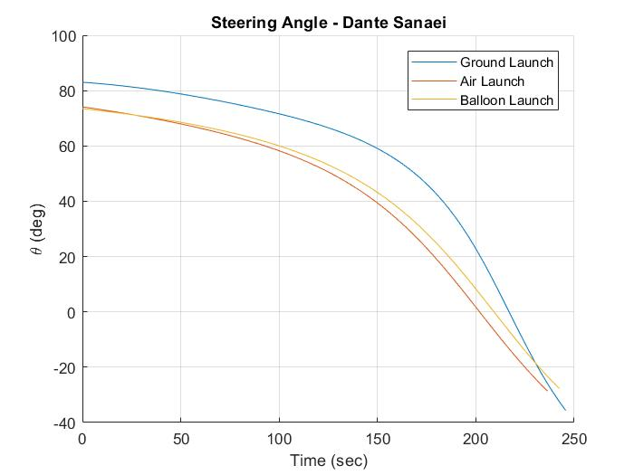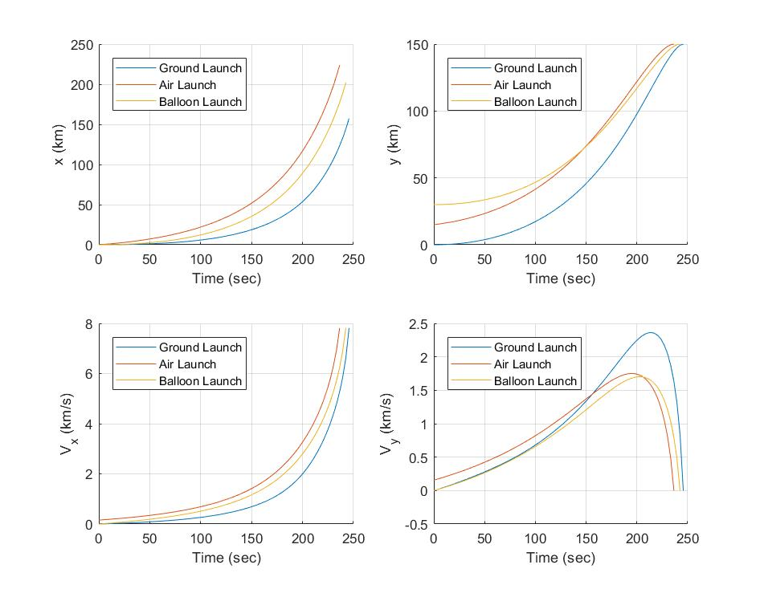

**State Variables – Dante Sanaei**

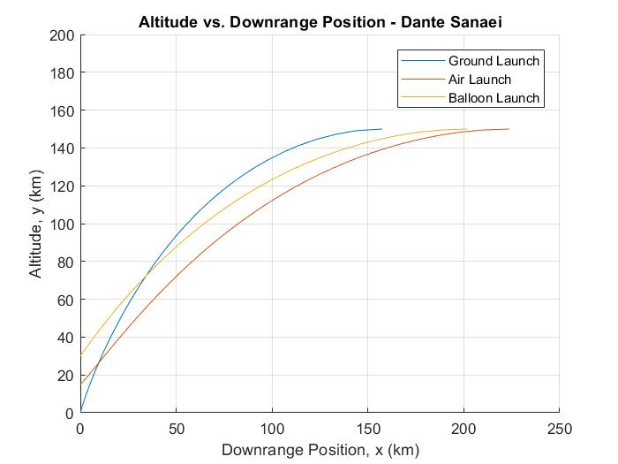

**Figure 3.1 Time Optimal Launch to Orbit of Titan II from Ground, Aircraft and Balloon. a) Steering Angle b) State Variables c) Altitude vs Downrange Position**

From the plots above we can see a definite difference between all three of the launch types. Interestingly, the data for the air and balloon launches are quite similar, but both stray away from the ground launch curves. It seems that even though the balloon launch does not start with an initial velocity, the fact that it begins above much of the dense atmosphere allows it to match the aircraft launch. The clearest trend that can be noted is that the ground launch requires a greater amount of vertical velocity through its flight. In the Vy vs time plot, we can see that at around 150 seconds into flight, the ground launched Titan gains a much larger amount of vertical velocity than the other launch types. This phenomenon can also be seen in the steering angle plot, as the ground launched curve remains closer to 90 degrees than the other launch types. This data most likely is a result of the rocket being forced to combat a far greater amount of drag loss in the thick early parts of the atmosphere. Because of this initial drag, the control angle must remain closer to 90 degrees to help the rocket break through the atmosphere, thus gaining a much larger amount of vertical speed throughout its flight. Because the final condition of flight requires vertical velocity to be zero, the ground launched rocket must spend more time than the others burning its extra Vy. This means that the ground launched vehicle is the least optimal in a strictly time sense, therefore also burning the most amount of fuel.

If we are to look more closely at the balloon and aircraft launches, we see that there is surprisingly little that differentiates them. Even though they began at different initial altitudes and velocities, their steering angle and time of flight remained nearly identical. The main difference that can be noted is the final x position in which they reached orbit. It is clear that the aircraft launched rocket reached its final orbit at a greater horizontal distance than the balloon. This seems to be due to the air launch requiring less vertical steering angles through its flight. Most likely due to its initial velocity, it spent began gaining horizontal velocity far earlier than the balloon launch. While the state and steering angle plots are quite similar for the balloon and air launch, the trajectory itself still is quite different, thus proving that small differences in control through flight can create a large disparity in the final trajectory (in our case, nearly 25 km in downrange position).

While the outcomes of the time optimal Titan II simulation were fascinating, the practical applications of this study are little to none. Launching a massive 1960s era rocket off of an aircraft or balloon is nonsensical and practically impossible. Therefore, our next step must be to look at more realistic spacecraft. Fortunately, in today’s burgeoning commercial space market, there are several novel examples of air launched, single stage rockets that we can utilize for a new simulation.

*2. More Realistic Air Launched Orbital Insertion Examples*

If we are to look for current era aircraft launched, single-stage rocket examples, the most obvious must be Virgin Galactic’s SpaceShipTwo. This spacecraft is being developed to launch from a custom-built aircraft, and it will allow its crew and passengers to enter a suborbital trajectory after launch [5]. While its orbital capabilities are not developed yet, for the purposes of this paper we can assume that its thrust is higher than in real life, and it is able to reach the final orbit used in our model. Additionally, we will evaluate Generation Orbit’s GOLauncher One, as it is a more traditional non-crewed, single stage rocket that is launched from a Gulfstream jet. The GOLauncher One was developed to enter suborbital trajectories in order to assist in hypersonic and low gravity research [6]. Like SpaceShipTwo, we will hypothetically assume that it is able to reach our desired final orbit for the purposes of this report. Because balloon launches have proven to be quite similar to aircraft launches in the Titan II analysis as well as their rarity in today’s space market, no balloon examples will be evaluated.

It is important to note that The GOLauncher One was recently updated and renamed to the X-60A, but since there is minimal data on the update and new craft, this paper will still consider the GOLauncher [6].

After thorough research into these two spacecrafts the following data has been found [1][7][8][11],

**Table 3.2 Spacecraft Parameters and Initial Conditions for Realistic Air Launched Rockets**

|  |  |  |
| --- | --- | --- |
| Spacecraft Parameters | SpaceShipTwo | GOLauncher 1 |
| Thrust ($kN$) | 270 | 250 |
| Initial Mass ($m$) | 13154 | 5700 |
| Mass Flow Rate ($\dot{m}$) | 112 | 65 |
| Drag Coefficient ($C_{D}$) | .3 | .1 |
| Cross Sectional Area ( $m^{2})$ | 4.15 | .19 |
| Initial Altitude ($km$) | 15 | 10 |
| Initial Velocity ($km/s$) | 55 | 220 |

As we see above the GOLauncher is a much smaller and more lightweight rocket due to its smaller payload. The initial velocity for the SpaceShipTwo is also much lower due to it being launched from a heavier aircraft, while the GOLauncher uses a modified passenger jet which can obtain much higher cruising speeds. While the GOLauncher begins at a faster velocity, it will be launched from a lower altitude due to the limits of its aircraft. Lastly, the mass flow rates for both rockets were estimated from the total fuel mass and their burn time.

After running the time-optimal orbital ascent model the following plots have been generated,

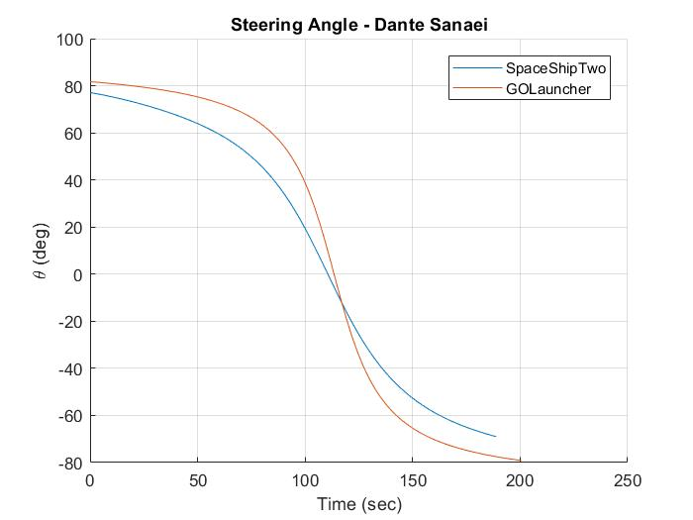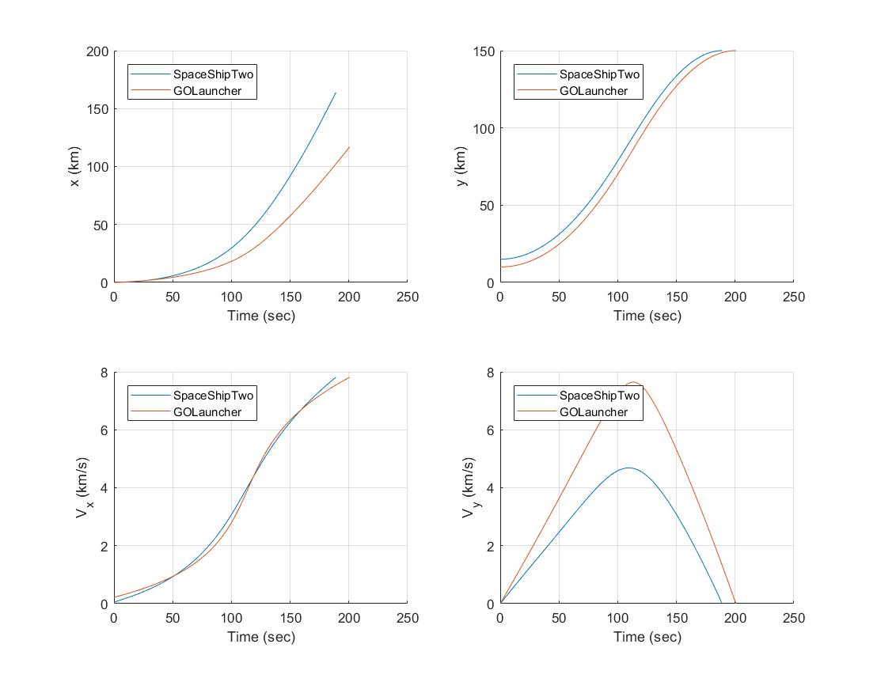

**State Variables – Dante Sanaei**

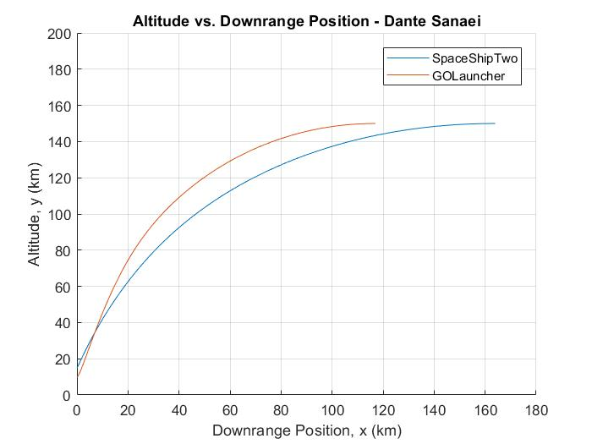

**Figure 3.2 Time Optimal Air Launch to Orbit of SpaceShipTwo and GOLauncher I. a) Steering Angle b) State Variables c) Altitude vs Downrange Position**

When these new applications are compared with the Titan II launch plots, we can see that while the general trend of all of the curves remained the same, there are several key differences that are present. For one, it is interesting to note that the steering angle plot for both the SpaceShipTwo and GOLauncher rockets begin at a near vertical position, and by the end of the flight, their control angle has nearly completely flipped 180 degrees. While the Titan launches began at the same near vertical angle (~80 degrees), it would only reach around -30 degrees at the end of its flight. Additionally, the Titan launches all experienced a similar exponential increase in its horizontal velocity, but the GOLauncher and SpaceShipTwo models show a completely different trend over time. Lastly, all launches using this time-optimal model show a large increase followed by an equally significant decline in vertical velocity (Vy) by the end of the flight. But in Figure 3.2b, we see a nearly parabolic arc for both vehicles. In the same plot, the Titan II did not remove the excess vertical velocity until far closer to the end of its flight – giving it an unsymmetrical curve.

While comparisons to the Titan Launches are valuable, we can also assess differences and similarities between trends in the launches of SpaceShipTwo and GOLauncher. While these spacecrafts have very different initial masses, they both had surprisingly similar trajectories, steering angles, and state variable curves. Even though it was a heavier vehicle, Virgin’s SpaceShipTwo reached its final destination in a quicker time, but its final downrange position was far greater than its counterpart. If we are to look at the horizontal position over time plots for both launches, we see that at around 75 seconds, SpaceShipTwo diverges from the GOLauncher and gains downrange distance at a much greater rate. Another major difference between these launches was the massive increase in vertical velocity by the GOLauncher. While both crafts have similar arcs in their vertical velocity (Vy), the GOLauncher gains nearly twice the amount of velocity by midflight. This can be assumed to be due to its quicker vertical ascent (seen in the altitude vs downrange position plot), and also due to the vehicle weighing nearly half of the SpaceShipTwo.

**B. Suborbital Applications for Air Launched Rockets**

While evaluating the trajectories and other data from a time optimal launch of Virgin’s SpaceShipTwo and Generation Orbit’s GOLauncher provides us a significant amount of information in the study of air launched rockets, neither of these vehicles are currently able to actually reach orbit. Instead, these rockets are meant for suborbital travel; Virgin Galactic’s vehicle is meant to carry a crew and passengers into space for a few fleeting moments, and the GOLauncher is built to perform low gravity and hypersonic research through suborbital flights. Additionally, both these spacecrafts are intended not intended to be launched at near vertical initial angles, so determining optimal launch angles will also be of importance. Therefore, the next step in the analysis of these spacecraft is to attempt to optimize their suborbital trajectories.

Unfortunately, suborbital optimization is significantly more difficult, as reaching apogee in a time optimal manner is not a chief priority. Additionally, there are a huge number of external variables that need to be considered (such as drag loss, re-entry speed, angle, etc.) [9]. But we can broadly assume that for both these launch craft, their goal is to spend the highest amount of time in space as possible.

Therefore, we will inspect simple ballistic trajectories of these rockets to determine if optimization is possible. One of the most prominent projectile optimization strategies is range optimization, so we will begin by utilizing a model that maximizes range for these rockets. Once range has been maximized, different launch angles will be studied to determine if time in space can be increased.

*1. Suborbital Air Launched Spacecraft Trajectory Analysis*

To begin our analysis of suborbital launches of the air launched examples from part one (SpaceShipTwo and GOLauncher I), we will plot their hypothetical trajectory if the maximization of range is the main objective. The model will use the same global parameters used for the time optimal code, and the same vehicle data given in Table 3.2. In addition to these values, the burn time for both vehicles will be necessary. From research into both of these spacecrafts, we can determine that SpaceShipTwo has a burn time of 87 seconds and the GOLauncher I have a burn time of 60 seconds[1][7].

We will assume that the earth is flat and drag losses will not be considered. Additionally, we will assume that the vehicles have a constant mass and thrust throughout flight.

First, we will determine both the maximum range, time in space, and the optimal launch angles for both vehicles,

Table 3.3 Range Optimized Values for SpaceShipTwo and GOLauncher

|  |  |  |
| --- | --- | --- |
| Parameters | SpaceShipTwo | GOLauncher |
| Optimal Angle (deg) | 49.5 | 46.87 |
| Coast Time in Space (sec) | 151 | 427 |
| Range from Ground Launch(km) | 437.8 | 1132.4 |
| Range from Air Launch (km) | 475.4 | 1289.3 |
| Apogee (km) | 110.8 | 308.9 |
| f/g | 2.82 | 6.04 |

We now can plot the trajectories for both launches,

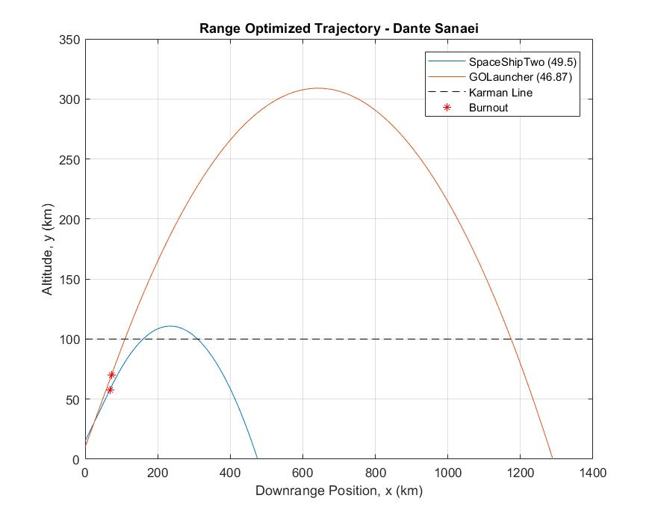

Figure 3.3 Range Optimized Trajectory for SpaceShipTwo and GOLauncher I

Both the data in the table and the trajectories in the figure above show a very clear trend: the GOLauncher is able to launch to a range that is far greater than SpaceShipTwo. Not only is this clear from the plot of the trajectories, we see that the GOLauncher rocket has nearly twice the maximum range (from ground and air), and also spends nearly four times as much coasting time in space. Even though the GOLauncher has less thrust than SpaceShipTwo, it is significantly lighter; thus, propelling the rocket much further into space. Unsurprisingly our model shows that the most vital vehicle parameter in the maximization of range is the mass.

We also see that the optimal angle is much higher for the heavier SpaceShipTwo and the optimal angle for the GOLauncher is much closer to 45 degrees. This is a favorable trend, as the theory behind range maximization states that as the value of $f/g$ approaches infinity, the optimal angle asymptotically approaches $π/2$ radians [2]. Because the gravitational value is constant for both launches, the GOLauncher has a higher $f/g$ value (6.04 compared to 2.84), thus its optimal angle is closer to 45 degrees.

Additionally, two range values have been calculated. The ground range is calculated from the maximum range equation given in section II.B., as this equation assumes the launch begins at x = y = 0. But our rockets begin with an initial velocity and initial altitude, thus we can experimentally determine the maximum range by finding the x intercept of the parabola generated during the coasting phase of flight. In both cases, the initial velocity and initial height extended the range of the rockets. More analysis on the range differences between ground and air launches will be performed in Section II.B.2.

While the data generated by our model has been fascinating, maximizing range for both rockets is not particularly useful for either of the mission profiles for these rockets. The primary target of both of these spacecrafts is to safely maximize the amount of time spent in space while also keeping cost and lift off mass as low as possible. For SpaceShipTwo, keeping the crew in space longer allows for a better experience (and more money), and the GOLauncher wants to maximize time in a weightless environment in order to facilitate more scientific experiments. Maximizing time is difficult because there are a lot of external variables that are evaluated [9].

In essence, the engineers for both of these spacecrafts face a complex multi-disciplinary optimization problem. If we assume that the launch velocity and altitude is constant, the following table from a paper on airborne launch optimization displays data from different launch angles,

Table 3.4 Important design characteristics for optimized air-launch in relation to initial flight path angle (From Ref. [10], P11)

|  |  |  |  |  |
| --- | --- | --- | --- | --- |
|  | 25° | 50° | 75° | 90° |
| Cost Per Flight (€M) | 1.930 | 1.830 | 1.902 | 1.904 |
| Gross Take Off Weight (kg) | 1017 | 931 | 924 | 968 |
| Gravity Loss (m/s) | 1586 | 1673 | 1875 | 1820 |
| Drag Loss (m/s) | 347 | 176 | 125 | 148 |

The table shows that choosing a launch angle is not simply an optimal control problem, as there are many different factors that should be considered. But our report only encompasses the problem of trajectory optimization, so we will assume that time in space is of primary importance. Table 3.4 will be used in the consideration of other parameters for the sake of realism.

Additionally, re-entry to earth’s atmosphere should be evaluated in our analysis. For objects entering the atmosphere, peak entry deceleration is a function of the sine of the entry angle and square of the entry airspeed [3], therefore high initial launch angles will directly increase the deceleration the vehicle faces upon entry. While modern day spacecraft may be able to tolerate these temperatures and pressures that will be faced upon a high entry angle/speed entry, we will assume for the sake of this analysis that our vehicles will not be able to handle atmospheric re-entry for trajectories with initial launch angles above 80°.

If we are to assume that both crafts are launched in a similar manner to the range optimization case (constant steering angle until burnout), then we can experiment with the initial angle to visualize possible suborbital trajectories.

The following are trajectories of both the SpaceShipTwo and the GOLauncher from the first angle that allows them to enter space (above Kármán line) until 80 degrees (we assume re-entry speed will be too high for launches above 80 degrees).

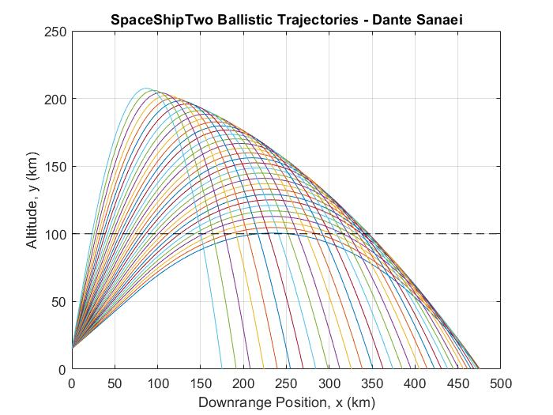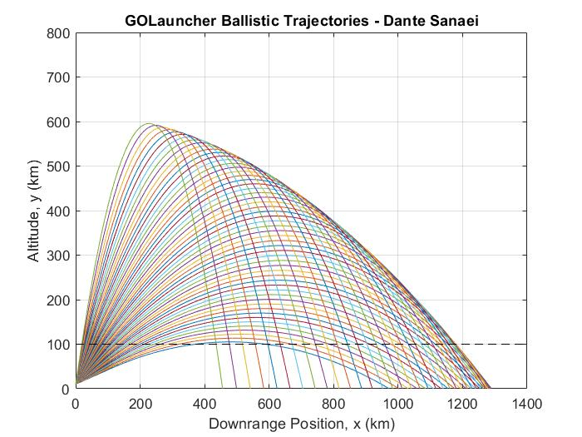

Figure 3.4 Experimentation of Initial Angle of Launch for a) SpaceShipTwo and b) GOLauncher

As we can see above, initial launch angles above the optimal solution produce higher trajectories – thus more time in space. If we are to assume that re-entry speed and angle is a major issue for both rockets, we would want to choose an initial starting angle somewhere in the middle of these trajectories. In order to better understand how time in space is related to the initial angle the following plot has been produced,

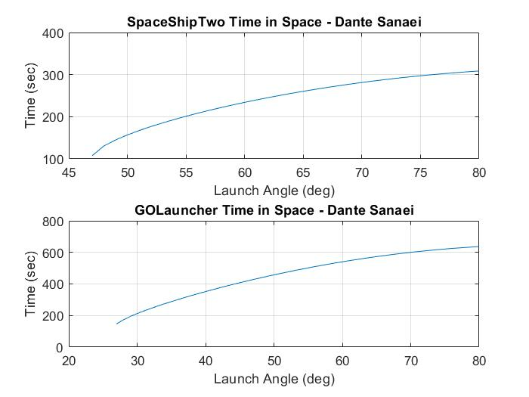

Figure 3.5 Time in Space vs Launch Angle for SpaceShipTwo and GOLauncher

The plots above show a near logarithmic curve as launch angle is increased. With the use of these plots, we can choose an optimal angle of launch to keep the craft in space for a satisfactory length of time.

From the analysis of Table 3.4, we see that launch angles between 50° and 75° produces the optimal results in terms of cost, lift off weight, and drag/gravity losses. With the help of the plot in Figure 4.5, we will choose a 65° launch for SpaceShipTwo and a 70° launch for the GOLauncher. From these choices, get nearly 250 seconds and 600 seconds in space, respectively. Now we can generate new data and also plot the trajectories.

Table 3.5 Optimal Time in Space Values for SpaceShipTwo and GOLauncher

|  |  |  |
| --- | --- | --- |
| Parameters | SpaceShipTwo | GOLauncher I |
| Chosen Angle (deg) | 65 | 70 |
| Maximized Coast Time in Space (sec) | 260.4 | 427 |
| Optimal Range (km) | 475.4 | 1289.3 |
| New Range (km) | 385 | 852.5 |
| New Apogee (km) | 151 | 538 |

The new launch angle trajectories (along with the optimal range trajectory) are seen below,

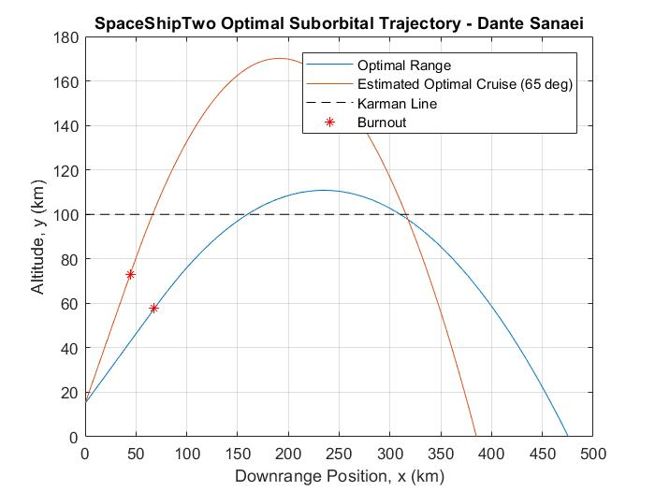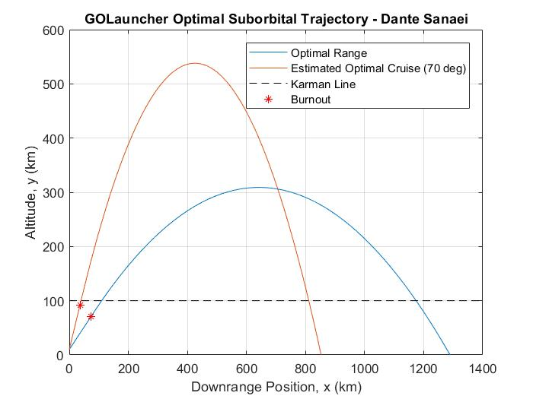

Figure 3.6 Optimal Range and Chosen Optimal Time in Space Trajectory. a) SpaceShipTwo b) GOLauncher

What is abundantly clear from the figure above is that the trajectory for the optimal range will produce less time in space than a higher launch angle. For both vehicles, dramatically increasing the initial steering angle reduces the final downrange position of the parabola; but as mentioned previously, final range of the spacecraft is not a consideration for either mission – instead both rockets want to spend as much time above 100km as possible (within reason). When comparing the data in Table 3.5, we see that the GOLauncher lasts four times longer in space than SpaceShipTwo.

While the range of the new trajectories were shortened, the apogee altitude for both new launch angles were greatly increased. In the range optimal case, SpaceShipTwo barely made it over the Kármán line, but with a higher launch angle, the vehicle was able to clear it by nearly 50 km. The GOLauncher craft experienced a similar trend as it nearly reached burnout above the Kármán line.

Overall, it is clear that the initial launch angle for both of these rockets is extremely critical to their missions. The fact that they are launched from the air allows them to more easily start with this initial optimal angle, since the aircraft can pitch upwards during launch. Overall, it is clear that the engineers who design and plan these flights must be cognizant of the results determined above, and plan trajectories that maximize time in space while also considering reentry speed, drag/gravity loss and other important design factors.

While the optimization of range was studied for these two air launched crafts, neither would realistically benefit from the optimization of range in any way. Therefore, it is important to find a new example that would see real benefit from the theory of range maximization. In the following section we will look at trajectories of a missile launched from the air and the ground.

*2. Range Optimal Missile Launch from Ground and Air*

While they are not the most recent technology, surface to surface missiles are still a critical tool employed by the United States military and other militaries around the world. Range optimization is one of the most useful theories in the successful application of these missiles. In this section we will assume that the GOLauncher rocket analyzed previously is also able to act as a long-range ballistic missile. As the main purpose of this report is to evaluate air launched rocketry, we will analyze range optimized trajectories of this warhead from a ground and air launch.

Since this is a military application, we can assume that the air launch of the missile is no longer on the Gulfstream jet (like in the previous section). Instead, we can use the top speed and altitude of an F-16 jet to obtain the initial conditions of launch. Thus, the air launch of the missile will take place at 10 km and at a velocity of 650 m/s [10]. By numerically solving for the optimal angle, both launches will maintain a constant 46.86° steering angle through powered ascent.

If the rest of the vehicle data is the same as the GOLauncher, the following data and plot can be generated,

**Table 3.6 Range Optimized Missile Launch from Air and Ground Data**

|  |  |  |
| --- | --- | --- |
|  | Ground Launch | Air Launch |
| Range (km) | 1133.3 | 1601.7 |
| Apogee (km) | 264.8 | 383.19 |

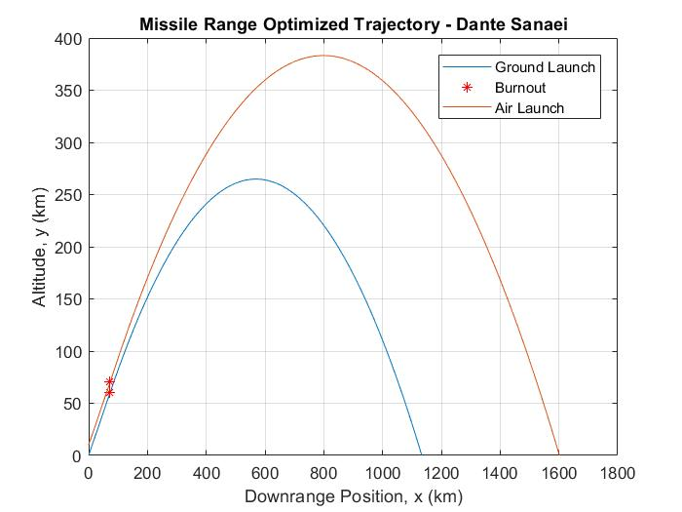

**Figure 3.7 Range Optimized Missile Trajectory from Air and Ground**

From the data and plot above we are able to easily discern that the air launch was able to propel the missile to a much further range and apogee than the ground launch. The initial velocity and altitude provided by the F-16 jet played a major role in extending the range of this missile. Not only has the range increased by nearly 500 km, but the air launched missile reached an altitude 100 km higher than the ground launch while also remaining in the air for a longer duration. It is easily to conclude that air launched missiles are the better choice when maximizing range of the warhead.

**IV. Conclusions and Future Work**

**A. Time Optimal Launches to Orbit Conclusions**

*1. The Titan II ground time optimal launch required a steeper climb than the Titan air launches.*

From the Titan II launch data seen in Figure 3.1, we are able to determine that the primary difference between the ground launch and the air launches was the climb rate. This finding can be directly visualized in the altitude vs downrange position plot (2d trajectory), as the ground launched Titan reaches its final orbital velocity and altitude far before the air launches. This can be better understood through the steering angle data; through a majority of the flight, the ground launched rocket required a higher angle (closer to 90°) than the other two launches. Therefore, the ground launch was slower to change its trajectory from a vertical ascent to a horizontal orbit. This is most likely due to excess drag loss that the ground launched Titan II had to face, as it had to traverse the thickest parts of Earth’s atmosphere. While the final times for each launch were nearly equal, we can clearly see that the air and balloon launches were able to gain less vertical velocity through their flights.

*2. the Aircraft and Balloon Launched Titan II rockets had very similar time-optimal trajectories, steering angles, and state data.*

Figure 3.1 also displays a surprising similarity between the ground and balloon launched Titan II rockets. While the balloon launch was able to reach its final orbit around 20 km before the aircraft launch, the rest of the data was quite similar. The steering angle, horizontal velocity, and altitude curves also all proved nearly identical for for both air launches. This result can allow us to conclude that the initial velocity of the air launch was balanced out by the higher initial altitude of the balloon. Due to the higher complexity and costs associated with a balloon launch, it seems that an aircraft launch from a lower altitude would be a better choice and it would still produce similar results (from a time-optimal perspective). Further analysis on this topic from a multi-disciplinary view would be required in order to make better judgements on the validity of a balloon launch to orbit.

*2. Current single stage air launched vehicles cannot reach orbit without greater burn times, but their lower masses allow them to gain velocity at higher rates.*

While air launches of the Titan II are wildly improbable due to its massive size, more realistic vehicles like Virgin Galactic’s SpaceShipTwo and Generation Orbit’s GOLauncher One (now X-60A) still can not reach orbit without additional stages. While we assumed that their fuel efficiency was high enough to produce over 150 seconds of sustained burn for the purposes of analysis, the real-life data for these spacecraft proves that only suborbital flight is possible. Even though these assumptions were made, both these vehicles helped prove the advantages of air launched rocketry from a time optimal standpoint. The plots for the state variables in Figure 3.2 show a very high rate of increase and decrease of vertical velocity. Due to their lower mass, these rockets can gain and lose velocity far quicker than larger ground launched rockets. This allows them to save fuel, thus increasing payload mass and launch costs. Overall, Single stage air launched rockets can be a very effective tool for scientific research, nano satellites, and space tourism, but propulsive technology must first advance before they can enter stable orbits.

**B. Suborbital Trajectory Optimization Conclusions**

*1. Vehicles with higher $f/g$* *values will have a greater range and an optimal angle closer to 45°*

The mathematical principles behind projective range optimization states that as f/g approaches infinity, range will approach infinity and the optimal angle will approach 45°*.* This is best proven by the range optimized trajectories in Figure 3.3. Due to the GOLauncher having significantly less mass than SpaceShipTwo, it has a noticeably higher $f/g$ value (6.04 compared to 2.82). As predicted, the trajectory for the GOLauncher reaches a range nearly 600 km further and an apogee than SpaceShipTwo. Not only is the range significantly greater, the optimal angle for the GOLauncher is much closer to 45° than SpaceShipTwo. Even though range is not of importance to either spacecraft, we are able to prove the basic mathematical principles that govern range optimization – if a rocket powered projectile is required to travel further, it must increase its $f/g$ value. The obvious future work that is required for this section of the analysis is the addition of drag and variable mass to the optimization mode. A.E. Bryson was able to develop and solve a similar short-range rocket optimal control problem that included drag and minimized fuel through the use of calculus of variations and by formulating it as a Mayer problem [11]. Replicating his work would be the logical next step.

*2. Launch angles between 50° and 75° are optimal for suborbital spacecraft*

Choosing the initial angle, velocity and altitude of air launched rockets is very much a multi-disciplinary optimization problem. There is no optimal control model that will be able to determine the best initial angle for the launch of SpaceShipTwo or the GOLauncher, as there are many different variables that engineers must consider [9]. From table 3.4 we are able to determine that angles between 50° and 75° would be most probable in a mission using the vehicles identified in this report. Through the iteration of initial launch angles (seen in Figure 3.4), we are able to visualize launch trajectories inside and outside this range. For the SpaceShipTwo, most launches that occurred below 50° resulted in apogees that were below the Kármánline, and with the addition of drag loss we can be fairly sure than almost all launches in this region would not enter space. Additionally, for both vehicles, launches above 75° resulted in trajectories with high speed and sharp atmospheric re-entry. From a strictly trajectory optimization sense, we can determine that maximizing time spent in space is the overall goal of both air launched rockets. Not only does the table prove that launches within 50° to 75° are best, but Figure 3.5 also shows us that time spent in space is relatively high in this range as well. Overall, from a multi-disciplinary and trajectory standpoint, we can safely say that suborbital air launches should remain within this optimal angular range.

*3. Increasing the initial velocity and altitude of rocket launches dramatically increases the range.*

It was proven earlier that higher thrust to weight ratios for rockets will increase their maximum range, but if $f/g$ remains constant, initial velocity and altitude that is provided from an air launch will help propel the rocket projectile further than a launch on the ground. Through Figure 3.7, we are able to see that the air launch of the same GOLauncher derived missile is able to travel nearly 500 km further downrange than a ground launch. Even if we are to ignore the increased drag losses that a ground launched missile would face, the initial velocity and altitude gained from its carrier aircraft (in this case an F-16 jet) will allow the air launched missile to fly higher and further. This is a very crucial discovery because it proves that in its most basic trajectory (no variable control during powered flight), an air to surface missile will have a greater maximum range than a surface to surface missile. This fact is one of the reasons that most medium and long range missiles are no longer launched from the surface.

**V. References.**

[1] Muir, S. A., “Air-Launch to Orbit,” University of Colorado Boulder, 2014.

[2] Longuski, J. M., Guzmán José J., and Prussing, J. E., “Some Applications,” *Optimal Control with Aerospace Applications*, New York, NY: Springer, 2014, pp. 131–166, 222–233.

[3] Sarigul-Klijn, M., Sarigul-Klijn, N., “Flight Mechanics of Manned Sub-Orbital Reusable Launch Vehicles with Recommendations for Launch and Recovery”, AIAA Journal, Vol. 9, No. 9, 2003, pp. 11-112

[4] “Red Bull Stratos II,” *StratCat* Available: http://stratocat.com.ar/fichas-e/2012/RIC-20120725.htm.

[5] “Virgin Galactic Reveals SpaceshipTwo Cabin Interior,” *Virgin Galactic* Available: https://www.virgingalactic.com/articles/virgin-galactic-reveals-spaceshiptwo-cabin-interior/.

[6] *X-60A: Future of Hypersonics* Available: https://generationorbit.com/x-60a/.

[7] Deng, A., “Aerodynamic Performance Prediction of SpaceShipTwo,” 2012, 10.13140/RG.2.1.3540.4885.

[8] “Final Environmental Assessment for the Launch and Reentry of SpaceShipTwo Reusable Suborbital Rockets at the Mojave Air and Space Port,” Federal Aviation Administration, Office of Commercial Space Transportation, May 2012

[9] Van Kesteren, M. W., “Air Launch versus Ground Launch: A Multidisciplinary Design Optimization Study of Expendable Launch Vehicles on Cost and Performance,” M.S. thesis, Faculty of Aerospace Engineering, Delft University of Technology, 2013.

[10] van Kesteren M.W., Zandbergen B.T.C, Naeije M.C, “Design and Analysis of an Airborne, solid Propelled, Nanosatellite Launch Vehicle using Multidisciplinary Design Optimization*,” 6th European Conference for Aeronautics and Space Sciences*, Krakow, Poland.

[11] “Gulfstream GII Performance and Specifications,” *PriJet* Available: https://prijet.com/performance/Gulfstream%20GII.

[12] Bryson A.E. Jr, Ross, S.E., “Optimum Rocket Trajectories with Aerodynamic Drag”, Harvard University, Cambridge MA, 1958

**VI. Appendix**

All MATLAB code is published and attached on the next page.